|  |  |  |
| --- | --- | --- |
| **Supervisor.** | Miss Summaiya |  |
| **Batch.** | 2303E1 |  |
| **Group.** | Pakistan |  |
| **Serial No.** | **Enrollment Number** | **Student Name** |
| 1. | 1460960 | Rubab Malick |
| 2. | 1463817 | Usman |
| 3. | 1455707 | Walli-ullah |
| 4. | 1459208 | Kanwal |

e-Project: calligraphy

# Quick Calligraphy

e-Project: Calligraphy

***ACKNOWLEDGEMENT***

The first, we would like to express my special thanks of gratitude to my teacher <<Miss Summaiya >>, who helped us a lot in finalizing this project within the limited time frame, valuable counselling and assistance for the accomplishment of this project.

Secondly we would also like to thank the e-Project team at Aptech Head Office, who gave us the golden opportunity to do this wonderful project about

Quick Calligraphy

Thirdly, we also thank the e-Project team, some of the benefits are as under:

* Re-enforcement of skills happens in the experiential learning process.
* A mentor, ensuring that we do not get drifted, constantly guides us.
* It gives us a lot of confidence to face an interview as we have worked on a project. We can explain virtually everything on the subject we have learnt.

1

e-Project: Calligraphy

***SYNOPSIS***

Calligraphy World is an immersive website offering a comprehensive learning experience in Arabic, Indic, and Greek calligraphy. Delve into the elegance of Arabic scripts like Naskh and Thuluth, master Indic scripts like Devanagari and Bengali, and explore Greek Uncial and Minuscule styles.

The platform provides step-by-step lessons, interactive practice tools, and cultural insights, fostering a deep appreciation for the beauty and significance of each script. Connect with a diverse calligraphy community, learn from renowned artists through video tutorials, and embark on a creative journey that celebrates the art and heritage of calligraphy from around the world.

2 e-Project: Calligraphy

***PROBLEM DEFINITION***

Calligraphy is the art of forming beautiful symbols by hand and arranging them well.

It&#39;s a set of skills and techniques for positioning and inscribing words so they show

integrity, harmony, some sort of ancestry, rhythm and creative fire.

Calligraphy can be taken to expert heights. Calligraphy skills are used in many areas

of art and graphics, from greetings card design to tattoo artistry. But you don&#39;t have

to be a pro to express your creative self and have a pleasant effect on the viewer or

recipient of your efforts.

Essentially, there are three main types of calligraphy: Western, Arabic, and Oriental.

Within each style, there may be several lettering sub-styles or hands. Seeing

examples of these styles can help you perfect your art and get inspired to create

something amazing.

Here we are aiming to design a website “QuickCalligraphy” which will provide an easy

way to learn calligraphy and provide the basic other details about the art. will support progress tracking and multi-language accessibility, ensuring a seamless learning experience across various devices. Security measures will be implemented to safeguard user data, and regular updates will be provided to keep the platform dynamic and relevant. The ultimate goal is to create an inclusive and inspiring platform that fosters a passion for calligraphy and celebrates its artistic heritage from different cultural perspectives.

e-Project: Calligraphy

***AGGREGATED SITEMAP***

Quick Calligraphy

(1.index.html)

Quick Calligraphy

(0.welcome.html)

Object : Quick Calligraphy

***SITEMAP ENGLISH***

Quick Calligraphy

( index.html)

Home page

(index.html)

Arabic calligraphy

(Arabic.html)

Origin Page

(origin.html)

Indic calligraphy

(indic.html)

Greek calligraphy

(Greek.html)

Categories page

Contect page

(contect.html)

Tools page

(tools.html)

***WIREFRAMES***

1. Main Layout

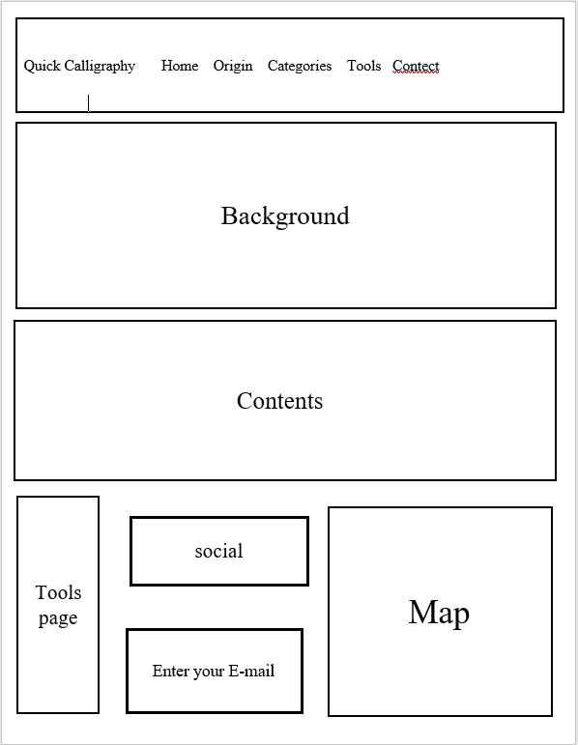

1.Home page (index.html)

Quick Calligraphy Home Origin Categories Tools Contect

Learning

History

script

Principles

footer

Socials links

Known About Calligraphy

2. origin page (origin.html)

content

Image

Image

Arabic Calligraphy

3.Categories page

Image

Greek Alphabet

Adoption

Image

Image

Greek Calligraphy

3. categories page

History

Image

Image

The Indic alphabet

Indic Calligraphy

3. categories page

Quick Calligraphy Home Origin Categories Tools Contect

4.Tools page (tools.html)

Cards

Cards

Cards

Cards

Cards

Cards

Footer

Sukra pen Touch calligraphy Marker

Canson Calligraphy Spiral Sketch

William Mitchell Calligraphy

Italic Dip pen

William Mitchell Calligraphy Selection

Sukra pen touch calligraphy

Arabic calligraphy Bambo Qalam Reed pen

Quick Calligraphy Home Origin Categories Tools Contect

5.Contect page (contect.html)

Footer

Map

Website name

Enter your Message

First Name

E-Mail Adress

Second Name

Contact us

e-Project: calligraphy

***TASK SHEET REVIEW***

|  |  |  |  |  |  |  |
| --- | --- | --- | --- | --- | --- | --- |
| Project Ref. No.: e-P/Advertisement Portal Management System/01 | | Project title | Date of Preparation of Activity Plan | | | |
| No | Task |  | Actual | Actual | Team-mate | Status |
| Start Date | Days | Names |
| 1 | Build Home Page | 30/June/23 | 5 | Rubab | Complete |
| **2** | Build Product  Page And  Product Line-Up  Pages | 10/July/23 | 3 | Usman | Complete |
| **3** | Build Contact page | 25/July/23 | 4 | Walli-ullah | Complete |
| 4 | Build logo | 15/July/23 | 2 | Walli-ullah | Complete |
|  |  | 9/July/23 | 15 | Rubab  Usman | Complete |
| **5** | Search content | Aura  Watch |  |  |  |  |
| 6 | Documentation | 25/July/23 | 7 | Rubab  Usman | Complete |
| 7 | Build About page | 15/July/YY | 5 | Rubab | Complete |
|  |  | | | | | |
| 8 | Search Themes  And images |  | 5/July/23 | 10 | Usman Rubab | Complete |
|  |  |  |  |  |  |
| 9 | Effort In website |  | All Days | 25 | Usman Rubab walliullah | Complete |